Notes: Anti-Patterns & Null Object Pattern

PART 1: Anti-Patterns

Introduction
- Context: Up to this point in the series, we studied SOLID principles and Design Patterns. We learned that design patterns are solutions to common problems.
- What are Anti-Patterns? Anti-patterns are things you accidentally do wrong in your code that cause problems later. They are common bad practices that should be avoided.
- Key Mindset: SOLID principles are not hard-and-fast rules; sometimes we take trade-offs to keep the application simple. Similarly, anti-patterns are patterns to recognize and avoid.

1. God Object
- What it is: A class or object that has been given too many responsibilities — it becomes a central hub for most operations in the application.
- Example: A class A with many methods M1, M2, M3, ... handling far too many different things.
- Problems caused:
  - The entire application becomes tightly coupled to this one class.
  - If a bug appears in this class, the entire application can fail.
  - Violates Single Responsibility Principle (SRP).
- Is an Orchestration Object a God Object?
  - Depends: If the orchestration object only delegates work to other objects (like a Facade), it is not a God Object.
  - If it performs operations itself and then delegates, and handles many concerns in every method, it becomes a God Object.
  - It may also introduce errors along with breaking SRP.
- Best Practice: Keep the orchestration object simple — it should only delegate. It can serve as a single entry point for the application, but should not handle everything itself.
- Real-World Example: In API/microservice architecture (e.g., Spring Boot), the Controller layer is a single entry point with API endpoints (e.g., v1/addUser, v1/removeUser, v1/updateUser). If the controller only routes requests to service-layer objects, it is not a God Object. The distinction can sometimes be subtle and must be identified carefully.

2. Spaghetti Code
- What it is: Code that is so complicated that there is no clear entry point or exit point. Multiple classes are tightly coupled in confusing ways (e.g., A depends on B, B on C, C on D, D back on A), with many loops and complex dependencies.
- Problems caused:
  - The application becomes highly tightly coupled.
  - Prone to errors — many chances for bugs.
- Key Takeaway: Avoid writing code where the flow is impossible to trace.

3. Hard Coding Things
- What it is: Embedding values directly into constructors or methods (e.g., String s = "hello"; hardcoded inside a method).
- Problem: You assume the value will never change. If it changes later, you must modify the code everywhere.
- Best Practice:
  - Pass values via parameters, constants, or configuration.
  - Only hardcode values when you are certain they will never change.

4. Gold Plating / Over-Engineering
- What it is: Trying to make the application "perfect" by applying every design pattern, principle, and OOP concept everywhere.
- Problem: You end up handling scenarios that will never occur in reality. For example, making every algorithm a Strategy with multiple concrete strategies even when the behavior never varies.
- Connection to Strategy Pattern: The Strategy pattern says "extract what varies." Gold plating is making everything a strategy, even things that don't vary.
- Best Practice: Only add complexity for scenarios that are realistic and likely. Avoid designing for hypothetical future cases that may never arise.

5. DRY Violation (Do Not Repeat Yourself)
- What it is: Copy-pasting the same code from one method to another (e.g., M1, M2, M3 all containing almost identical code).
- Problem: If the logic changes, you must update it in every method where it was copied.
- Best Practice:
  - Extract repeated code into a separate method, utility class, or separate hierarchy.
  - Have M1, M2, M3 directly use the extracted logic.
- Note: DRY is one of the first principles taught when learning OOP.

6. Constructor Overloading (Constructor Telescoping)
- What it is: Creating many overloaded constructors for a class.
- Also called: Constructor Telescoping.
- Solution: Use the Builder Design Pattern instead of overloading constructors.
- Key Takeaway: Avoid constructor overloading to prevent this anti-pattern.

7. Overuse of Getters and Setters
- What it is: Generating getters and setters for every variable without thinking about whether they are needed.
- Why it's a problem:
  - Members were made private specifically so they cannot be accessed from outside.
  - Getters/setters were introduced so that access goes through validation — you control which fields can be read or written.
  - Modern IDEs auto-generate getters/setters for all variables, which is wrong.
- Best Practice: Decide which getters and setters are actually needed. Not every variable should have both.

8. Premature Optimization
- What it is: Optimizing code before it works correctly.
- Guiding Principle: "Make it work, then make it fast."
- Example (from DSA): When sorting an array, first use a brute-force approach (e.g., O(n²)) to get it working. Then optimize to O(n log n) using better approaches.
- Best Practice: First ensure the application does what it is intended to do. Only then optimize for performance.

9. Inheritance Overuse
- What it is: Using inheritance excessively, creating deep or multiple inheritance hierarchies.
- Problem: Makes code very complicated.
- Solution: Use composition (has-a relationship) instead of inheritance wherever possible.
- Patterns that help reduce inheritance:
  - Strategy Pattern
  - Visitor Pattern
  - Bridge Pattern
- Best Practice:
  - Use inheritance only through abstract classes.
  - For concrete implementations, prefer composition.
- Note: This was discussed in the very first video of the design patterns series ("Why Inheritance is Bad").

Summary of All 9 Anti-Patterns
# | Anti-Pattern | Core Problem
1 | God Object | One class handles too many responsibilities; tight coupling
2 | Spaghetti Code | No clear entry/exit; highly coupled; error-prone
3 | Hard Coding Things | Values embedded directly; inflexible
4 | Gold Plating / Over-Engineering | Handling scenarios that will never occur
5 | DRY Violation | Copy-pasting code instead of extracting it
6 | Constructor Overloading / Telescoping | Too many overloaded constructors
7 | Overuse of Getters/Setters | Exposing all fields without need or validation
8 | Premature Optimization | Optimizing before the code works
9 | Inheritance Overuse | Deep inheritance hierarchies; should prefer composition
- Benefits of avoiding anti-patterns: Better (loosely coupled) code, easier to apply design patterns, faster integration of new features, and no getting stuck in confusing code.

PART 2: Null Object Pattern

What is the Null Object Pattern?
- Core Idea: Avoid null checks in your code by providing a "null object" — a concrete object that does nothing (or returns default values) instead of using null.
- What it replaces: Instead of writing if (obj1 == null) { ... } everywhere, you always provide a valid object reference — either a real concrete object or a Null Object.
- Why avoid null checks?
  - You might forget to write the check, leading to a NullPointerException (e.g., calling obj1.m1() when obj1 is null).
  - If you pass obj1 as a parameter to another method, that method might forget to check for null and directly call obj1.m1(), causing an exception.
  - OOP principle: "Replace conditionals with polymorphism" — minimize if-else statements by using polymorphic behavior.

UML Structure
- Abstract Class (e.g., AbstractClass) with a method m1().
- Concrete Class — inherits from the abstract class and overrides m1() with real logic.
- Null Object Class — also inherits from the abstract class and overrides m1() with empty/default behavior:
  - Either leave the method body empty.
  - Or return a default value (e.g., 0, empty string, etc.).
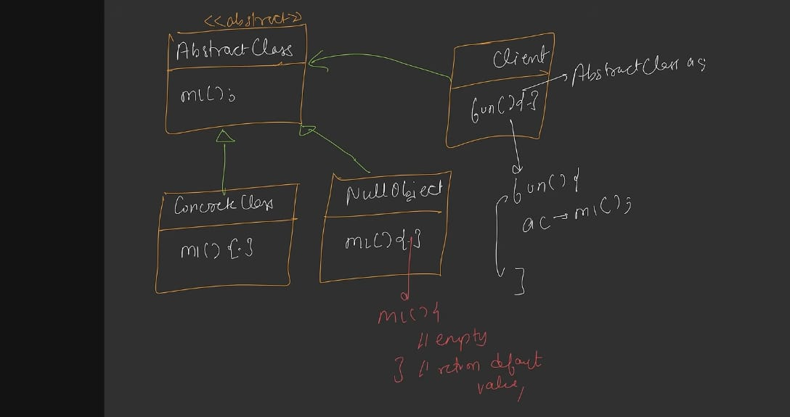

How It Works
- Client holds a reference to the Abstract Class (e.g., AC).
- Without Null Object Pattern:
text
if (AC != null) {
AC.m1();
}
- With Null Object Pattern:
text
AC.m1(); // Always safe — AC is either a real object or a Null Object
- When you have "nothing" to pass, you pass an instance of the Null Object instead of null.
- The Null Object's m1() does nothing — no exception is thrown.

Key Concepts
- null vs Null Object:
  - null means the reference points to no object in heap memory (like a dangling pointer). Calling a method on it throws NullPointerException.
  - A Null Object is a real object in heap memory that does nothing. Calling its methods is safe — it returns defaults or does nothing.
- Liskov Substitution Principle (LSP): The Null Object is a valid substitute for the abstract class — LSP is not broken because the Null Object behaves correctly (does nothing) without throwing exceptions.

Examples from Previous Design Patterns
The Null Object Pattern was already used in earlier videos in the series:
- Strategy Design Pattern (Robot Example):
  - IRobot has a fly strategy (IFlyStrategy).
  - Concrete strategies: FlyWithWings, FlyWithJet.
  - For robots that cannot fly, instead of storing null, we created a NoFlyBehavior (Null Object) that overrides fly() with an empty body.
  - Result: Calling s.fly() never throws an exception, and no null check is needed.
- Command Design Pattern (Remote Control Example):
  - ICommand is the parent interface.
  - Concrete commands exist for various actions.
  - Initially, all buttons on the remote were assigned a NoCommand (Null Object) that overrides the execute method with an empty body.
  - Result: Pressing a button does nothing but does not crash — no null check needed.

Benefits
- Eliminates if (something == null) checks throughout the code.
- Prevents NullPointerException.
- Makes code cleaner and more polymorphic.
- Can be inserted into any design pattern where an object might be null.

Standard Definition
The Null Object Pattern says: Avoid null checks in your code by providing a Null Object — a concrete object that does nothing (or returns default values) — so that a valid reference is always available, and no NullPointerException occurs.

